CST 2309 Lab 2.1 – Maximo Antigua

Refer to Tutorial 1: Getting Started with HTML page

1. Complete Session 1.1 from pages HTML 1 to HTML 20

Add a screenshot of the **ct_about.html** file displayed in a browser after completing Step 3 on page HTML 19. Include the address bar in the screenshot

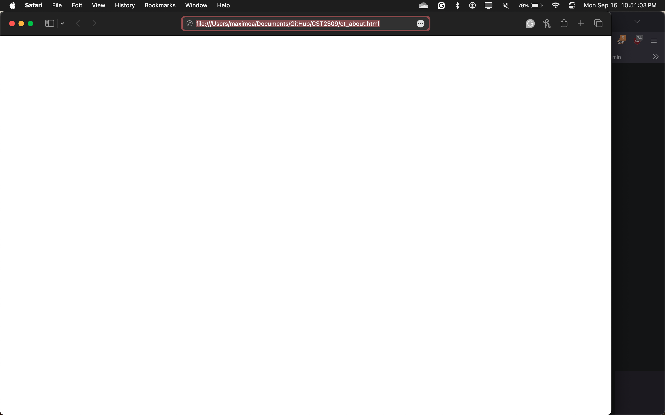

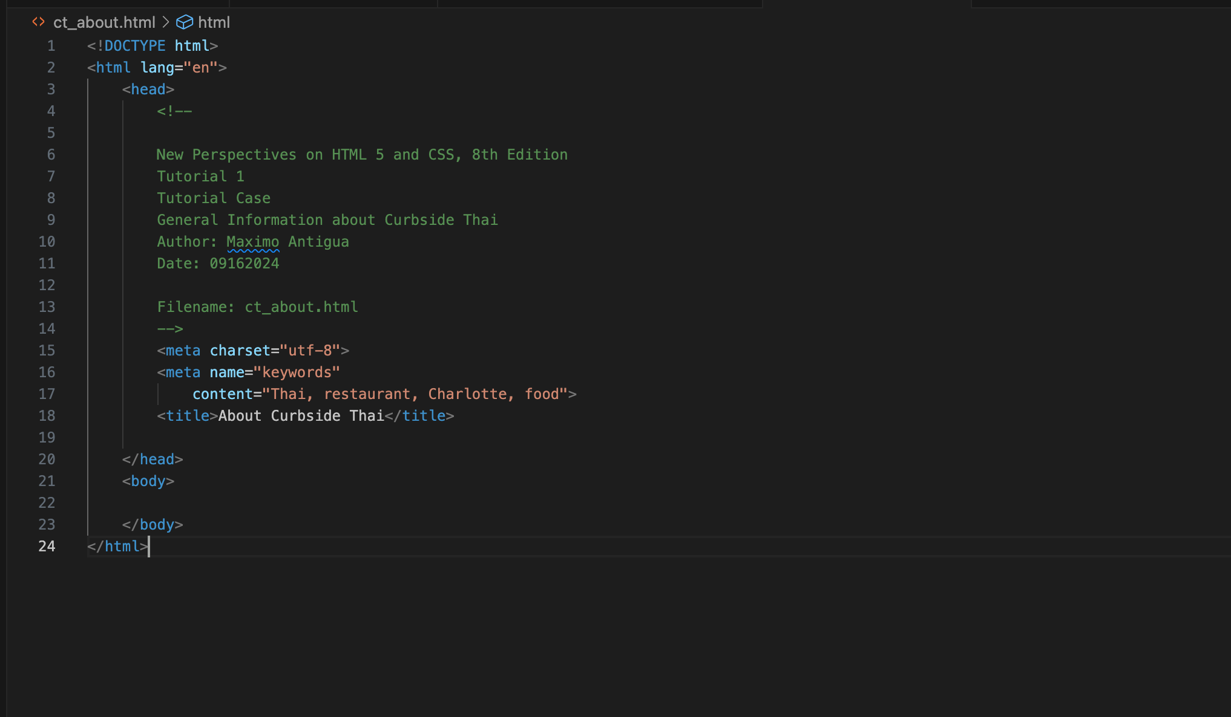

1. Complete the Session 1.1 Quick Check.

Completed.